Programa en Turbo Pascal – programado por “El príncipe en computación”.
https://www.youtube.com/@elprincipeencomputacion1401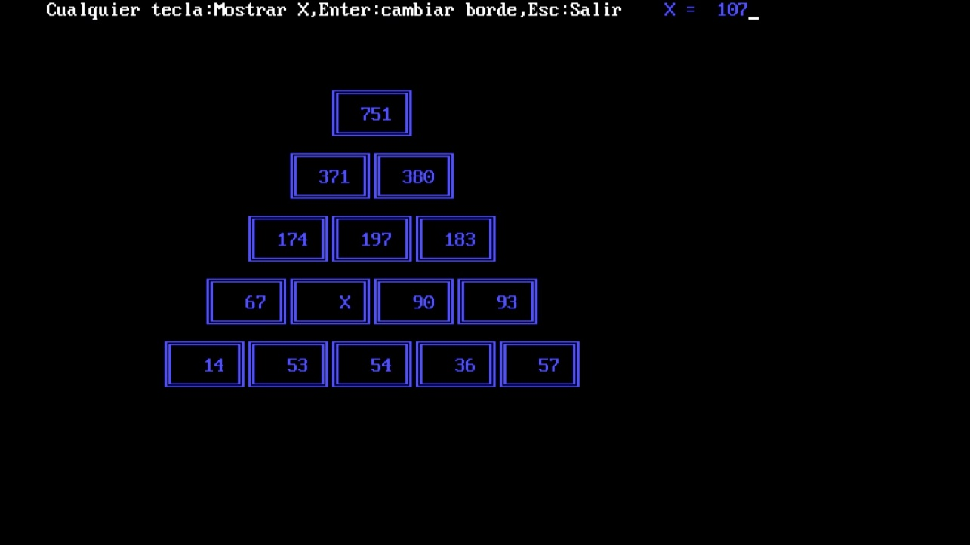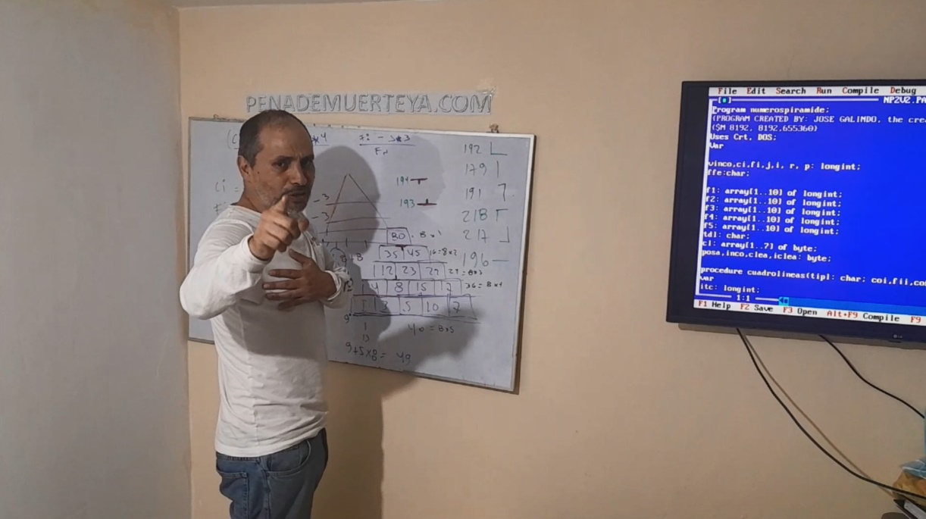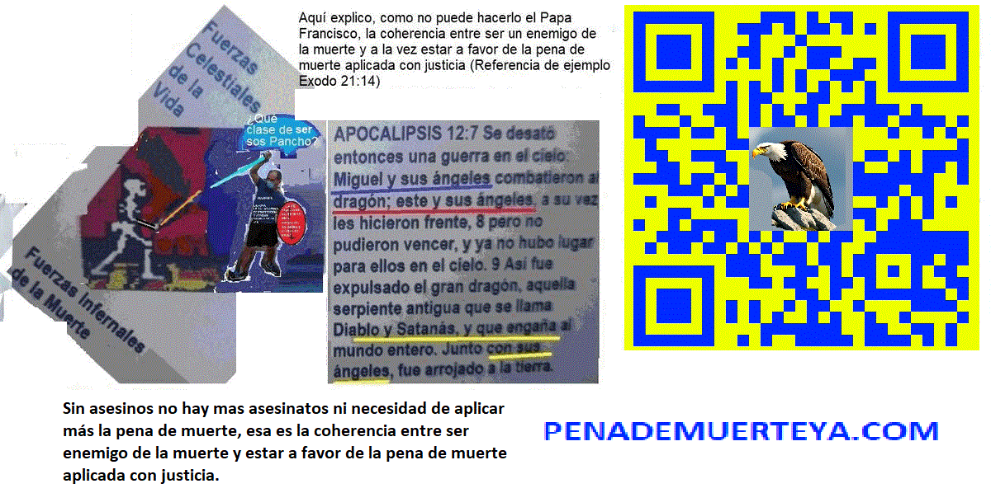

https://youtu.be/FKSyzsT0dyk
Program numerospiramide;
{PROGRAM CREATED BY: JOSE GALINDO, the creator of penademuerteya.com, eltestimoniodegabriel.link and lavirgenmecreera.com}
{$M 8192, 8192,655360}
Uses Crt, DOS;
Var

vinco,ci,fi,j,i, r, p: longint;
ffe:char;

f1: array[1..10] of longint;
f2: array[1..10] of longint;
f3: array[1..10] of longint;
f4: array[1..10] of longint;
f5: array[1..10] of longint;
tdl: char;
cl: array[1..7] of byte;
posa,inco,clea,iclea: byte;

procedure cuadrolineas(tipl: char; coi,fii,cof, fif: longint);
var
itc: longint;
horizontal,vertical, supizq,supder,infizq,infder:char;
begin
if tipl='s' then
begin
horizontal:=chr(196);vertical:=chr(179); supizq:=chr(218);supder:=chr(191);infizq:=chr(192);infder:=chr(217);
end
else
begin
horizontal:=chr(205);vertical:=chr(186); supizq:=chr(201);supder:=chr(187);infizq:=chr(200);infder:=chr(188);
end;
gotoxy(coi,fii);
write(supizq);
for itc:=1 to ((cof-coi)-1) do
write(horizontal);
write(supder);
gotoxy(coi,fif);
write(infizq);
for itc:=1 to ((cof-coi)-1) do
write(horizontal);
write(infder);
for itc:=1 to ((fif-fii)-1) do
begin
gotoxy(coi,fii+itc);write(vertical);
gotoxy(cof,fii+itc);write(vertical);
end;
end;

Begin
tdl:='s';
{Black 0
Blue 1
Green 2
Cyan 3
Red 4
Magenta 5
Brown 6
LightGray 7
DarkGray 8
LightBlue 9
LightGreen 10
LightCyan 11
LightRed 12
LightMagenta 13
Yellow 14
White 15}
cl[1]:=15;
cl[2]:=9;
cl[3]:=10;
cl[4]:=14;
cl[5]:=12;
cl[6]:=3;
cl[7]:=11;
randomize;

Repeat
posa:=0;
inco:=random(15)+1;
clrscr;
write('Cualquier tecla:Mostrar X,Enter:cambiar borde,Esc:Salir');
iclea:=random(6)+1;
clea:=cl[iclea];
textcolor(clea);
for j:=1 to 10 do
begin
f1[j]:=0;
f2[j]:=0;
f3[j]:=0;
f4[j]:=0;
f5[j]:=0;
end;
for r:=1 to 5 do
f1[r]:=random(100);
for r:=1 to 4 do
f2[r]:=f1[r]+f1[r+1];
for r:=1 to 3 do
f3[r]:=f2[r]+f2[r+1];
for r:=1 to 2 do
f4[r]:=f3[r]+f3[r+1];
for r:=1 to 1 do
f5[r]:=f4[r]+f4[r+1];
ci:=random(30)+1;
fi:=random(7)+18;
for j:=1 to 5 do
begin
for i:=1 to 6-j do
begin
cuadrolineas(tdl,((ci+i*8)+j*4)-1,(fi-j*3)-1,((ci+i*8)+j*4)+6, (fi-j*3)+1);
gotoxy((ci+i*8)+j*4,fi-j*3);
posa:=posa+1;
if posa=inco then
begin
write('X':5);
case j of
1:vinco:=f1[i];
2:vinco:=f2[i];
3:vinco:=f3[i];
4:vinco:=f4[i];
5:vinco:=f5[i];
end;
end
else
case j of
1:write(f1[i]:5);
2:write(f2[i]:5);
3:write(f3[i]:5);
4:write(f4[i]:5);
5:write(f5[i]:5);
end;
end;
end;
ffe:=readkey;
if ffe=#0 then
ffe:=readkey;
if ffe=#13 then
if tdl='d' then
tdl:='s'
else
tdl:='d';
gotoxy(60,1);write('X =',vinco:5);
delay(1000);
Until ffe=#27;
End.
Este soy soy:
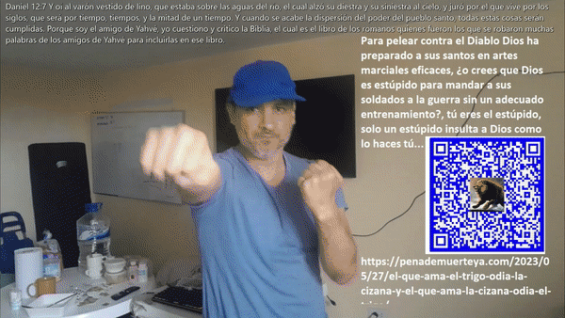
¿Cómo te quedó el ojo “Satanás”?, verás que soy entendido y no una “bestia” como tú…
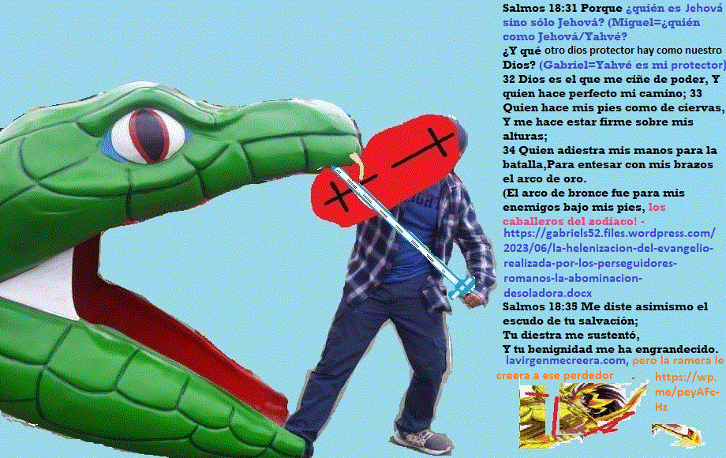

Sin mi virgen novia fiel, nada tiene gracia para mí, tú quédate con tus estatuas Satanás!
